Fear in DNA by Dennis Kelly

⚠️YOUR ESSAY MUST MEET ALL THE CRITERIA FOR THE INTRODUCTION, BODY PARAGRAPHS, AS WELL AS CONCLUSION; OTHERWISE, YOUR ESSAY WILL NOT BE MARKED! ⚠️ ⚠️⚠️⚠️⚠️⚠️⚠️⚠️⚠️⚠️⚠️⚠️⚠️⚠️⚠️⚠️⚠️⚠️⚠️⚠️⚠️⚠️⚠️⚠️⚠️⚠️⚠️⚠️⚠️
⚠️COMPLETE THE COVER LIST BELOW TO ENSURE YOU HAVE MET ALL THE CRITERIA ⚠️

Cover Checklist-✅Tick Each Section When Complete.
- PREP STEP - Make a copy of this document.
- PREP STEP - Share your essay outline template with your tutor.
- PREP STEP - Copy and paste the link for your essay outline into your study system.
- STEP 1 - Outline your 100% essay - START WITH THE CONCLUSION & WORK BACKWARDS
- STEP 2 - Use the TTECEA checklist for details
- STEP 3 - Revise your essay - check for coherence & cohesion, redundant repetition, clarity, vocabulary, etc.
- STEP 4 - Edit your essay.
- STEP 5 - Put your essay together as one complete piece.

Table of Contents
100% ESSAY STRUCTURE OVERVIEW 2
STEP 1: OUTLINING - Complete Your 100% Essay Outline 4
STEP 2: ADDING DETAIL-Complete the TTECEA Checklist for Detail 8
STEP 3: REVISING - Revise Your Essay 9
STEP 4: EDITING - Edit Your Essay 10
STEP 5: COMPLETE - Put Your Essay Together as One Complete Piece 11

100% ESSAY STRUCTURE OVERVIEW

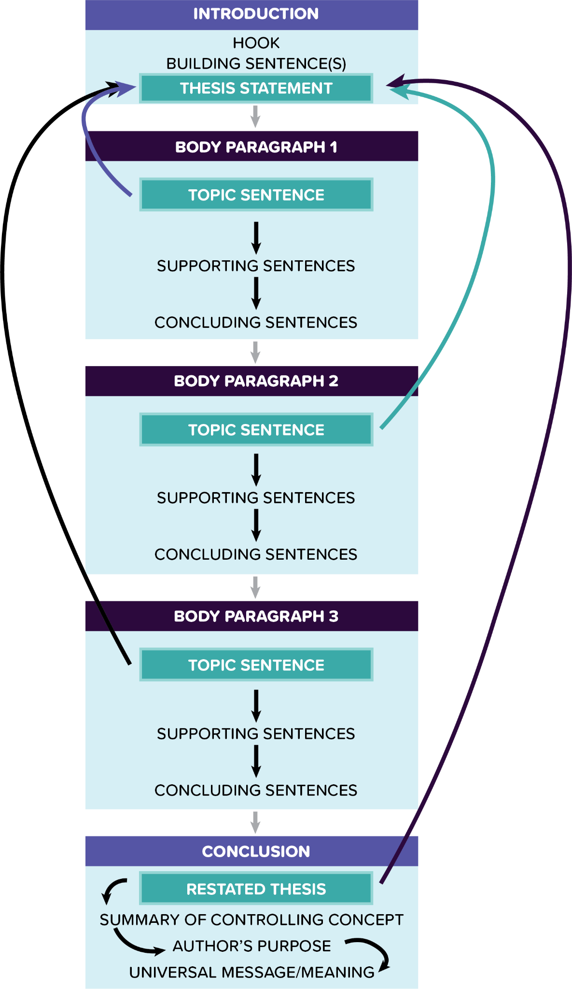

STEP 1: OUTLINING - Complete Your 100% Essay Outline

Criteria | Status | INTRODUCTION - Do not make this too detailed.
Hook AO1  fact/statistic | Complete  (only mark complete when steps 1-5 are ALL complete) | Similar to the most eminent playwrights, such as the Ancient Greeks, Elizabethans, Jacobeans, and modern authors like Caryl Churchill or Debbie Tucker Green, Dennis Kelly explores universal themes, such as love, death, violence, power, and fear.
Buiding sentence(s) AO3  - counter-argument  OR  - some contexual info | Complete  (only mark complete when steps 1-5 are ALL complete) | What sets Kelly apart, however, is his ability to seamlessly weave these ageless motifs into the daily lives of ordinary individuals in relatable, contemporary British settings. Accordingly, in his play "DNA," he presents fear as a dominant theme that permeates the experiences of the teenage characters.
Thesis statement AO1  - key idea 1  - key idea 2  - key idea 3 | Complete  (only mark complete when steps 1-5 are ALL complete) | Therefore, this essay will delve into the methods Kelly uses to present the pervasive theme of fear by employing various techniques such as the semantic field of fear, the deliberate exclusion of authority figures, and the strategic use of setting.
Criteria | Status | BODY PARAGRAPH 1 - only focus on KEY IDEA #1
WHAT? Topic sentence AO1  - key idea 1 | Complete  (only mark complete when steps 1-5 are ALL complete) | Leah, the protagonist of "DNA," asserts that all her fellow teenagers live in a constant state of fear, emphasising the immediate reason for this fear as the gang culture and bullying that threaten their physical and psychological well-being.
HOW? Supporting sentences AO2  - terminology  - evidence  - close analysis  - effects* | Complete  (only mark complete when steps 1-5 are ALL complete) | To illustrate, Dennis Kelly employs a semantic field of fear in Leah's quote, "the fear that everyone here lives in, the brutal terror, it scares me … Everyone's scared." In particular, the explicit use of the lexical choice of "fear," "brutal terror," and "scared" emphasises the pervasive and inescapable nature of the emotion experienced by the characters. Moreover, the phrase "everyone here lives in" suggests that fear is an ever-present, inescapable force, shaping the characters' existence and interactions; additionally, it also mirrors the real-life experiences of many individuals, such as those in the audience, who have faced bullying, gang culture, or oppressive social structures. Therefore, the vivid portrayal of fear evokes empathy and understanding, allowing the audience to connect with the characters and their personal as well as collective battles against fear.
WHY? Concluding sentence(s) AO2/AO3  - author’s purpose  - (final thought / context about the key idea) | Complete  (only mark complete when steps 1-5 are ALL complete) | Moreover, Kelly's own experiences support this notion, describing school as a 'dangerous and frightening place' where violence and extortion were used to assert dominance and terrorise others.
Criteria | Status | BODY PARAGRAPH 2 - only focus on KEY IDEA #2
WHAT? Topic sentence AO1  - key idea 2 | Complete  (only mark complete when steps 1-5 are ALL complete) | Another method Dennis employs to illustrate the theme of fear is by constructing the play so it deliberately excludes authority figures, such as parents, police and teachers.
HOW? Supporting sentences AO2  - terminology  - evidence  - close analysis  - effects* | Complete  (only mark complete when steps 1-5 are ALL complete) | Not only does this technique compel the audience to focus on the characters' experiences of fear and violence, but it also creates an atmosphere of isolation and vulnerability, amplifying for the audience, the fear experienced by the teenagers. One of the most tragic victims of the absence of authority figures is Brian, a sensitive, emotional teenage boy who is exploited by the gang members. Unlike Jan and Mark, John Tate and Lou, or Leah and Phil, neither Brian nor Adam feature as part of a pair, foregrounding the fact that they are lonely and alienated, and, thus, exposed and vulnerable with no adult figure to protect them. Kelly illustrates Brian’s fear via assonance when he says, “because I cry, they (the teachers) think I’m telling the truth, but I’m crying because I’m lying and I feel terrible inside.” On the one hand, the repetition of the /I/ sound in "crying," "lying," and "inside" appears to reflect his pain and can, therefore, deepen the audience’s empathy for him. On the other hand, however, the assonance also emphasises the contrasting ideas of truth and lies in the quote. The repeated vowel sounds in "cry," "think," "lying," and "inside" highlight the paradox of Brian's situation: he cries when he lies, and people believe him because of his tears. This draws the audience's attention to the theme of deception and manipulation that runs throughout the play, as characters navigate the complexities of their relationships, their responsibilities, and the consequences of their actions. Moreover, the use of assonance in this quote can be linked to the broader context of the play, in which fear, power dynamics, and the absence of authority figures contribute to an environment where deception and manipulation become survival tactics for the characters.
WHY? Concluding sentence(s) AO2/AO3  - author’s purpose  - (final thought / context about the key idea) | Complete  (only mark complete when steps 1-5 are ALL complete) | Brian's quote illustrates how even seemingly vulnerable characters can resort to lying and manipulation in a desperate attempt to navigate their complex and fearful world.
Criteria | Status | BODY PARAGRAPH 3 - only focus on KEY IDEA #3
WHAT? Topic sentence AO1  - key idea 3 | Complete  (only mark complete when steps 1-5 are ALL complete) | The setting also plays a crucial role in exploring the theme of fear and shaping the audience's experience.
HOW? Supporting sentences AO2  - terminology  - evidence  - close analysis  - effects* | Complete  (only mark complete when steps 1-5 are ALL complete) | Firstly, the lack of specificity in terms of decade and locality, as indicated by the absence of concrete details beyond the names of supermarkets or brands of sweets, allows the play to resonate with a wider audience, creating a sense of universality. Consequently, this vagueness in setting highlights the idea that fear, violence, and social dynamics are not confined to a particular time or place but are instead pervasive elements of human experience. Moreover, each of the settings, as stipulated in the stage directions - ‘a street’, ‘a field’, and ‘a wood’ - contributes to the theme of fear and serves a particular purpose in the narrative. For instance, the wood evokes the idea of wilderness and lawlessness, where conventional rules no longer apply. This association with fear and danger is rooted in cultural references such as Shakespeare's ‘King Lear’ or ‘A Midsummer Night's Dream’, William Golding’s ‘Lord of the Flies’ and numerous fairy tales like ‘Hansel and Gretel’. As a result, by setting parts of "DNA" in the wood, Kelly taps into this rich cultural history to heighten the audience's sense of fear and unease. Furthermore, Leah's references to chimpanzees and bonobos serve to emphasize the wild, primitive aspect of the characters' behaviour, reinforcing the notion that the group has regressed to a more primal state in the face of their fears and challenges.
WHY? Concluding sentence(s) AO2/AO3  - author’s purpose  - (final thought / context about the key idea) | Complete  (only mark complete when steps 1-5 are ALL complete) | In this way, the use of setting and cultural allusions helps to create a cohesive and engaging exploration of the theme of fear throughout the play.
Criteria | Status | CONCLUSION - CRUCIAL!
Restated thesis AO1  (Re-write your thesis statement in different words.) | Complete  (only mark complete when steps 1-5 are ALL complete) | In conclusion, Dennis Kelly portrays the all-encompassing theme of fear by utilising a range of methods, including the semantic field of fear, the intentional omission of authority figures, and the thoughtful manipulation of the setting.
Summary of controlling concept AO1  How does your thesis link to the central theme of the text? | Complete  (only mark complete when steps 1-5 are ALL complete) | The play appears to be structured around the exploration of how fear shapes the characters' actions and reactions. Fear manifests in various ways, from the fear of being caught and facing consequences to the fear of losing social standing within the group. This fear drives the teenagers to make morally questionable decisions and pushes them further into dark and dangerous situations.
Summary of author’s central purpose AO1/AO3  How does the controlling concept reflect the MAIN reason that the author wrote the text? | Complete  (only mark complete when steps 1-5 are ALL complete) | Consequently, DNA, just like Kelly’s other plays, connects with the contexts in which it was created, allowing readers, performers, directors, and audiences to employ their analytical skills in contemplating relevant social and political concerns, such as the murder of John Bulger, the Iraq war of 2003, terrorism, hidden torture sites like Guantanamo Bay, and The War on Terror. In light of these issues, Kelly says, ‘The play asks how much do the rights of the individual matter compared to the group?’
Universal message AO1  (What is the MAIN message of the text? Focus on the end.) | Complete  (only mark complete when steps 1-5 are ALL complete) | Ultimately, the play highlights the difficulties in ascertaining for whose benefit human rights have been compromised at the start of the twenty-first century. For specific ideologies, for individual nations, or for all humanity?

STEP 2: ADDING DETAIL-Complete the TTECEA Checklist for Detail

- To achieve a grade 9 level of detail, ensure that you link your key idea in each of your body paragraphs to as many of the elements of the TTECEA mnemonic as possible (aim to write about 650-950 words maximum for the entire essay)
- You do not need to have each of the TTECEA elements in each paragraph, but make sure you have all of them in the entirety of your essay.
- Each item on the checklist should only have 2 main purposes:
  - to link to your key idea in each paragraph
  - and support your argument.

- TOPIC SENTENCE: Introduce the key idea of your body paragraph.
- TECHNIQUE: Select a key technique the author uses (one you can explore in detail, eg, metaphor, simile, etc).
- EVIDENCE: EMBED a quote to back up your ideas.
- CLOSE ANALYSIS: Break the technique into smaller pieces, zoom in and analyse them PERCEPTIVELY.
- EFFECTS ON THE READER*: Explore what the author’s method makes us focus on, feel (emotionally) or think.
- AUTHOR’S PURPOSE: Explore why the might want to make us feel a certain way about certain ideas.

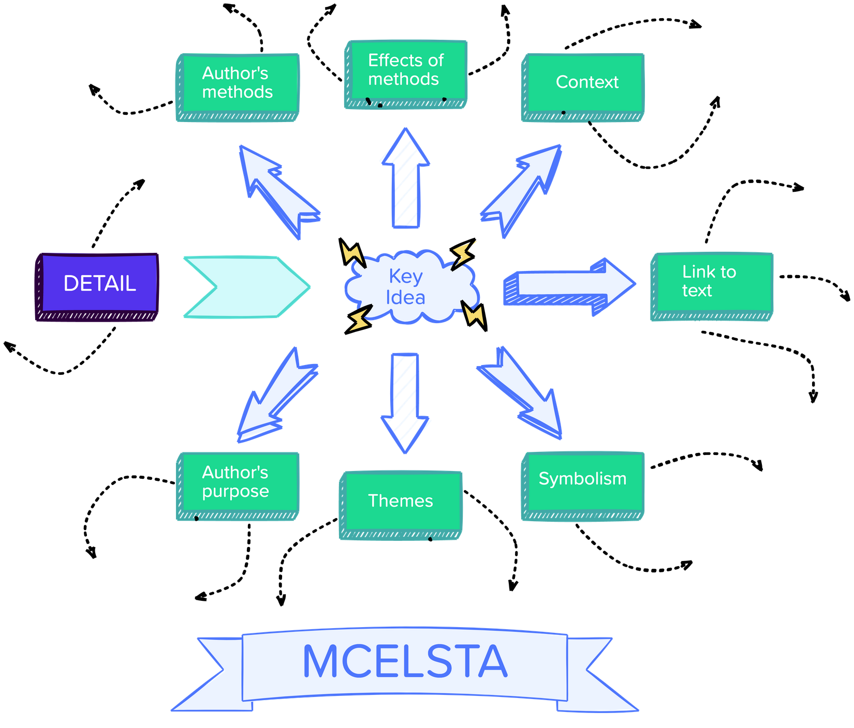

STEP 3: REVISING - Revise Your Essay

Ensure you have revised the following aspects of your essay:

- Removed/replaced ALL redundant repetition.
- Replaced ALL instances of the word ‘shows’ with more accurate and specific verbs for inferring effects of the author’s methods (check toolkit).
- Revised essay for coherence: are the ideas in each of the paragraphs clearly connected to each other?
- Revised essay for cohesion: check the toolkit for help.
- Removed all instances of the following words and replace them with specific details of the topics you are exploring:
  - How
  - Shows
  - Some
  - Something
  - Thing
  - This
  - Way
  - What
- Your vocabulary is academic - no informal language unless quoting directly.
- Revised essay for clarity—is your essay easy to read? Ask a peer to read it and give you feedback.

STEP 4: EDITING - Edit Your Essay

Ensure you have edited the following aspects of spelling, punctuation, and grammar:

- All words are spelt correctly.
- All sentences and names begin with a capital - see guidelines below ⬇️
- All sentences end with a full stop.
- ⚠️No sentences are separated with a comma!!!!!!!!!!!! 🤲
- I used a comma before and after the following words or phrases:
  - for example,
  - however
- I have used ellipses to indicate missing words in quotes.
- I have used at least one semi-colon to separate or join closely related sentences.
  - The language paper focuses on various forms of writing; the literature paper focuses primarily on academic essay writing.
  - There are five keys to a grade 9 essay: structure, conceptualisation, context, detail, and convincing evidence.
- I have used a colon to introduce a quote, phrase, word, etc.

HOW TO REMEMBER CAPITALS - ABLE PRINTS:

- Abbreviations: U.K., USA, UAE
- Beginnings of sentences: Nobody saw it coming.
- Languages: French, Spanish, Italian, Arabic,
- Emphasis - I LOVE CHEESE! (avoid this)

- Places: Africa, Mecca, London, Zimbabwe
- Religions and words related to them: Islam/Muslim, Christianity/Christian, Judaism/Jewish, Hinduism/Hindu
- I, as in me
- Names (specific) of people, places, businesses, e.g., Shakespeare, Apple, London.
- Titles of books, movies, or programmes, e.g., The Lion King, Macbeth,
- Special days: Eid, Christmas, Diwali

SPAG RULES

https://www.grammarly.com/blog/category/handbook/

STEP 5: COMPLETE - Put Your Essay Together as One Complete Piece

Similar to the most eminent playwrights, such as the Ancient Greeks, Elizabethans, Jacobeans, and modern authors like Caryl Churchill or Debbie Tucker Green, Dennis Kelly explores universal themes, such as love, death, violence, power, and fear. What sets Kelly apart, however, is his ability to seamlessly weave these ageless motifs into the daily lives of ordinary individuals in relatable, contemporary British settings. Accordingly, in his play "DNA," he presents fear as a dominant theme that permeates the experiences of the teenage characters. Therefore, this essay will delve into the methods Kelly uses to present the pervasive theme of fear by employing various techniques such as the semantic field of fear, the deliberate exclusion of authority figures, and the strategic use of setting.

Leah, the protagonist of "DNA," asserts that all her fellow teenagers live in a constant state of fear, emphasising the immediate reason for this fear as the gang culture and bullying that threaten their physical and psychological well-being. To illustrate, Dennis Kelly employs a semantic field of fear in Leah's quote, "the fear that everyone here lives in, the brutal terror, it scares me … Everyone's scared." In particular, the explicit use of the lexical choice of "fear," "brutal terror," and "scared" emphasises the pervasive and inescapable nature of the emotion experienced by the characters. Moreover, the phrase "everyone here lives in" suggests that fear is an ever-present, inescapable force, shaping the characters' existence and interactions; additionally, it also mirrors the real-life experiences of many individuals, such as those in the audience, who have faced bullying, gang culture, or oppressive social structures. Therefore, the vivid portrayal of fear evokes empathy and understanding, allowing the audience to connect with the characters and their personal as well as collective battles against fear. Moreover, Kelly's own experiences support this notion, describing school as a 'dangerous and frightening place' where violence and extortion were used to assert dominance and terrorise others.

Another method Dennis employs to illustrate the theme of fear is by constructing the play so it deliberately excludes authority figures, such as parents, police and teachers. Not only does this technique compel the audience to focus on the characters' experiences of fear and violence, but it also creates an atmosphere of isolation and vulnerability, amplifying for the audience, the fear experienced by the teenagers. One of the most tragic victims of the absence of authority figures is Brian, a sensitive, emotional teenage boy who is exploited by the gang members. Unlike Jan and Mark, John Tate and Lou, or Leah and Phil, neither Brian nor Adam feature as part of a pair, foregrounding the fact that they are lonely and alienated, and, thus, exposed and vulnerable with no adult figure to protect them. Kelly illustrates Brian’s fear via assonance when he says, “because I cry, they (the teachers) think I’m telling the truth, but I’m crying because I’m lying and I feel terrible inside.” On the one hand, the repetition of the /I/ sound in "crying," "lying," and "inside" appears to reflect his pain and can, therefore, deepen the audience’s empathy for him. On the other hand, however, the assonance also emphasises the contrasting ideas of truth and lies in the quote. The repeated vowel sounds in "cry," "think," "lying," and "inside" highlight the paradox of Brian's situation: he cries when he lies, and people believe him because of his tears. This draws the audience's attention to the theme of deception and manipulation that runs throughout the play, as characters navigate the complexities of their relationships, their responsibilities, and the consequences of their actions. Moreover, the use of assonance in this quote can be linked to the broader context of the play, in which fear, power dynamics, and the absence of authority figures contribute to an environment where deception and manipulation become survival tactics for the characters. Brian's quote illustrates how even seemingly vulnerable characters can resort to lying and manipulation in a desperate attempt to navigate their complex and fearful world.

The setting also plays a crucial role in exploring the theme of fear and shaping the audience's experience. Firstly, the lack of specificity in terms of decade and locality, as indicated by the absence of concrete details beyond the names of supermarkets or brands of sweets, allows the play to resonate with a wider audience, creating a sense of universality. Consequently, this vagueness in setting highlights the idea that fear, violence, and social dynamics are not confined to a particular time or place but are instead pervasive elements of human experience. Moreover, each of the settings, as stipulated in the stage directions - ‘a street’, ‘a field’, and ‘a wood’ - contributes to the theme of fear and serves a particular purpose in the narrative. For instance, the wood evokes the idea of wilderness and lawlessness, where conventional rules no longer apply. This association with fear and danger is rooted in cultural references such as Shakespeare's ‘King Lear’ or ‘A Midsummer Night's Dream’, William Golding’s Lord of the Flies and numerous fairy tales like Hansel and Gretel. As a result, by setting parts of "DNA" in the wood, Kelly taps into this rich cultural history to heighten the audience's sense of fear and unease. Furthermore, Leah's references to chimpanzees and bonobos serve to emphasize the wild, primitive aspect of the characters' behaviour, reinforcing the notion that the group has regressed to a more primal state in the face of their fears and challenges. In this way, the use of setting and cultural allusions helps to create a cohesive and engaging exploration of the theme of fear throughout the play.

In conclusion, Dennis Kelly portrays the all-encompassing theme of fear by utilising a range of methods, including the semantic field of fear, the intentional omission of authority figures, and the thoughtful manipulation of the setting. The play appears to be structured around the exploration of how fear shapes the characters' actions and reactions. Fear manifests in various ways, from the fear of being caught and facing consequences to the fear of losing social standing within the group. This fear drives the teenagers to make morally questionable decisions and pushes them further into dark and dangerous situations. Consequently, DNA, just like Kelly’s other plays, connects with the contexts in which it was created, allowing readers, performers, directors, and audiences to employ their analytical skills in contemplating relevant social and political concerns, such as the murder of John Bulger, the Iraq war of 2003, terrorism, hidden torture sites like Guantanamo Bay, and The War on Terror. In light of these issues, Kelly says, ‘The play asks how much do the rights of the individual matter compared to the group?’ Ultimately, the play highlights the difficulties in ascertaining for whose benefit human rights have been compromised at the start of the twenty-first century. For specific ideologies, for individual nations, or for all humanity?

